***Ақмола облысы***

***Еңбекшілдер ауданы***

***Еңбекшілдер орта мектебі***

**ТЕРЕМОК**

**(бастауыш сынып оқушыларына арналған сыныптан тыс іс –шара )**

**4- сынып**

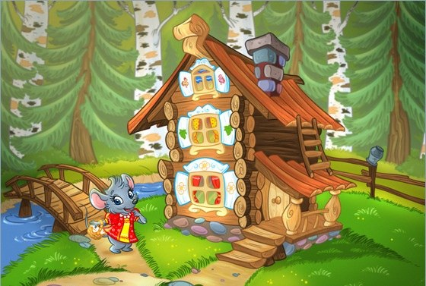

**Жауапты Амрина Ж. У.**

**2016-2017**

**Мақсаты:**

1. Оқушылардың оқу, сөйлеу қабілеттерін дамыту.

2. Оқушылардың пәнге деген қызығушылықтарын дамыту.

3. Оқушыларды ұйымшылдыққа тәрбиелеу.

Кейіпкерлер : Тышқан, Бақа, Түлкі, Ит. Музыкалық әуен ойналады.

Оқушылар ертегі кейіпкерлерінің  маскаларын киеді. Картоннан жасалған үйшіктің макеті.

*Mouse:*What a nice house! It is very nice, it is not small. It is not big. Tock, tock, tock. Who lives in the house? Nobody! Now I can live in it.

Скачет Лягушка, увидела домик.

*Frog:*What a nice house! Tock, tock, tock. Who lives in the house? *Mouse:*I live in the house. I am a mouse. And who are you?

*Frog:*I am a frog. My name is Green. And what is your name?

*Mouse:*My name is Mighty-Mouse. What can you do?

*Frog:*I can jump. I can sing *(изображает действия: скачет, квакает).*

*Mouse:*Sing a song, please!

*Frog(поет):*I have amother, I have a father, I have a brother, I have not a sister, I have not a grandmother, I have not a grandfather.

*Mouse:*Glad to see you. Come in. Let's live together in the house.

Бежит Собачка. Увидела дом.

*Dog:*Tock, tock, tock. Who lives in the house?

*Mouse:*I live in it. I am a mouse.

*Frog:*I live in the house. I am a frog. And who are you? Who are you?

*Dog:*I am a dog. I am clever. I am not ugly. I am pretty. I am not big. I am small.

*Frog:*What is your name?

*Dog*: My name is Jack

*Frog:*Can you dance?

*Dog:*Yes, I can. (Танцует собачий вальс и декламирует стихотворение)

I am a dog.

My name is Jack.

My coat is white,

My nose is black

*Mouse:* You are very nice. Come in. Let's live together.

Бежит лиса

*Fox:*I am a fox. I am very nice. I am pretty and clever. (Видит теремок). *:*What a nice house! Tock, tock, tock. Who lives in the house?

*Звери по очереди:* I am a mouse. I live in the house. I am a fox. I live in the house. I am a dog. I live in the house. Who are you?

*Fox:*I am a fox.

*Dog:*Can you read?

*Fox:* Yes, I can

*Dog:*Read, please.

 (Показывает карточки с текстами. Лиса громко читает и переводит)

Nick has got a pen. His pen is red. Ann has got a rabbits. Tim has got a grey cat. Bob has got a pink pig. His pink pig is big and fat.

A dog can jump. A cat can skip. But it can not swim. Big pig can not run. Bob must sing. But he can not run. Tom has got a cat. His cat is funny. A duck can not sing. A frog is ugly.

*Dog:*Come in. Let's live together.

Затем они приглашают из зала друзей. (Let's sing and dance together.)

Друзья в масках или с игрушками поднимаются на сцену и все поют песню "The More We Are Together".

Виео ролик “GOODBYE”